Exercise name | Muscle Targeted | Detail | Example
Shoulder Circle | Shoulders | Move shoulders forward and then backwards 15x ea. | 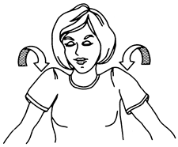
Side Neck Stretch | Neck | Gently tilt your head towards your shoulder. Assist stretch with a gentle pull on the side of the head. | 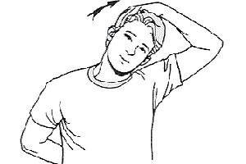
Wrist Flexion Stretch | Forearm extensors | - Hold out your arm with the palm facing down.  - Drop the fingers and palm at the wrist.  - Grab your fingers with the other hand and pull them towards the body.  - Hold the stretch.  - Repeat for the other hand. | 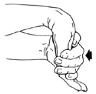
Wrist Extension | Forearm Flexors | - Hold out your arm with the palm facing down.  - Bend the fingers and palm at the wrist.  - Grab your fingers with the other hand and pull them back and towards the body.  - Hold the stretch.  - Repeat for the other hand. | 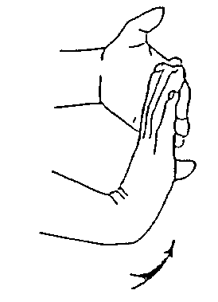
Overhead stretch | Abdominals, Forearms, Triceps | Stand straight, lace fingers together, palms facing upward, extend arms. | 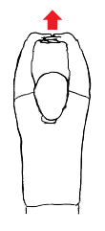
Overhead triceps | Triceps | Raise one arm and flex the elbow, attempting to touch your hand to your back. Hold your elbow with the other arm.
Shoulder Stretch | Shoulders | Reach your arm across your body and hold it straight. With the other hand, grasp your elbow and pull it across your body towards your chest. | 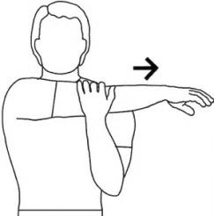
Hips Swing | Hips | - Rotate the hips clockwise while keeping the back straight.  - Repeat the action in a counterclockwise direction.  Do this three times in each direction. | 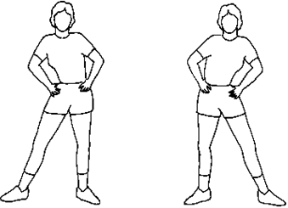
Knees and Ankles  Rotation | Knees and Ankles | - Stand with the feet together. And bend at the waist with the knees slightly bent.  - Place the hands above the knees, and rotate the legs in a clockwise direction. Repeat the action in a counterclockwise direction.  Do this 3 times in each direction. | 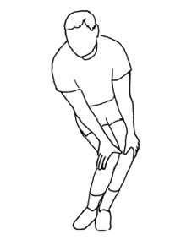
Ankles Stretch | Ankles | - Stand and hold onto something for balance  - Lift right foot and rotate foot and ankle 8 to 10 times clockwise, then 8 to 10 times counterclockwise.  - Repeat on other side (Note: can also be done sitting) | 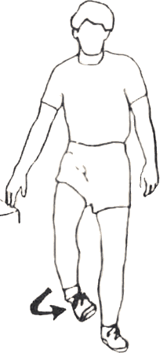
Hip Sitting Stretch | Piriformis  (muscle in the hip that enables lateral rotation of the leg) | - Lie on a comfortable surface  - With one leg straight, bend your other knee and place the ankle on the opposite side of the straight leg.  - Grab the knee and pull it across your body.  - Hold the stretch.  - Repeat for the other side. | 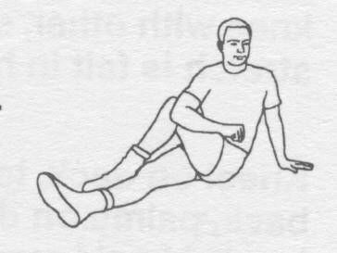
Seated Floor Harmstring Stretch | Harmstrings | - Sit on a mat with your right leg extended in front of you and your left leg bent with your foot against your right inner thigh.  - Lean forward from your hips and reach for your ankle until you feel a stretch in your hamstring. Repeat for the other side. | 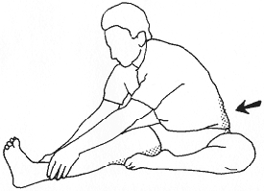
Standing Toe Touches | Harmstrings | Stand straight and bend at the waist, keeping your legs straight, relax and let your upper body hang down in front of you.  Let your arms and hands hang down naturally. | 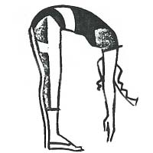
Cross-Leg Drop Stretch | Hamstrings | Without the band, cross your left foot over your right. Ideally you want your big toes in line, but go to where you feel comfortable balancing. Slowly walk your hands down your legs as far as feels comfortable; really relax your neck, as if your head were a bowling ball elongating your spine, and take three deep breaths into your back. Slowly come all the way back up to the starting position, cross your right foot over your left.
Straddle | Harmstrings, Calves | Begin in a seated, upright position. Start by extending your legs in front of you in a V.  With your hands on the floor, lean forward as far as possible. | 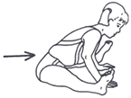
Squatting | Hamstrings | - Squat with feet and knees pointed outward  - Bring the elbows to the inside of the knees  - Roll your shoulders back  - Bring your shoulder blades together  - Feel a stretch in the inner thighs | 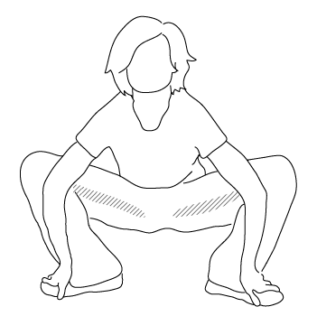
Standing Harmstrings Stretch | Harmstrings | A standing hamstrings stretch is performed from a bent over position.  Extend your right leg in front of your body, place your heel on the floor and rest your hands on your thigh. Keeping your right leg straight, bend your left knee and bend forward at the waist. | 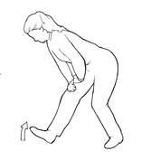
Butterfly Stretch | Groins and Inner Thighs | - Sit on the floor with your knees bent and soles of your feet touching.  - Grasp your feet and move your heels in toward your body as far possible while applying steady pressure on the inside of your thighs with your elbows.  The goal is to get the outside of your knees as close to the floor as possible. | 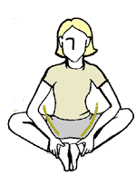
Quadriceps Stretch | Quadriceps | - Clasp your foot behind your body with opposite hand  - Pull your foot upwards, and push the knee backward  - Contract your abdominals to stabilize the pelvis (do not arch your back).  - Press the front hip bone forward and slightly extend the hip  - Hold the stretch  - Repeat for each leg | 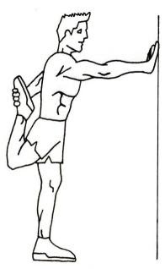

Further Recommendations:

- Jumping Jacks
- Jogging in place

Compiled by Janeth Velardo

